Notes from the Food Festival Working Group Meeting

Thursday 25th January 2024 10.30am in the George
Present: Sue Bains (SB), Judith Jackson (JJ), Sue Jeffries (SJ), Tadge Sabatowski (TS), Peter Cowley (PC)
Apologies: Duncan Cashmore (DC), Paul Macpherson (PM), Ed Young (EY), Harriet Smith (HS)

Membership of the Working Group
- Our job is to make the Food Festival Happen!
- We must be positive, realistic and work as a team – argue in meetings, back decisions out of meetings
- Positive criticism is welcome but no sharing of draining, irrelevant negative feedback
- No actions to be carried out until the notes from meeting are distributed
- No promises to anyone for anything – check with group
- Four areas within which all tasks are listed. (see handout)
  - Admin – SB
  - Publicity – PM
  - Logistics and H&S – JJ and SJ
  - Raffle, Tombola and sponsorship – DC
- Each group has a leader (and back-up) who should be able to report on updates at meetings and keeps oversight of all tasks in their area.
- All members can and should do anything from any group
- Volunteers and helpers are encouraged.

- Admin:
SB Updated group on current admin. The group agreed:
- Almost all spaces reserved so no general promotion required (see handout)
- Need Fudge/Chocolate stall
- Grant applied for from Shipston Town Council, but won’t hear until April
- 37 (3 metre) spaces reserved so far out of 40: 9 traders using 16 spaces bringing their own vans. 21 actual stalls reserved so far
ACTION: Members taken flyers to give to suitable traders (all)
ACTION: SB to chase non-payments (SB)
ACTION: SB to top & tail old policies* and distribute to members (SB)
ACTION: Members to check policies are comprehensive and relevant (all)
ACTION: SB to add members to Whatsapp group (SB)
Future actions to remember/consider
- Liaise with the Town’s traders group (around Easter?)
- Possibly offer Ambassador role to 15-18 year olds (around Easter?)
- All policies to go to Insurance company and to Stratford Safety Advisory Group

- Publicity:
SB Updated on what has been done so far
- Flyers advertising FF to traders have done a good job and no more required
- Website is live for applications
- Facebook – need to start sewing seeds
- Road Signs and banners were stored after the last FF, numbers can be changed
- New road signs need to be A0 size
Future actions to remember/consider
- Banners and Road signs need cleaning and checking
- SB to request information for website from traders and confirm booking details

- Logistics and H&S:
SB and SJ Updated on what has been done so far
- Road closure all ready for submitting application ?
- Relevant policies need checking
- Stalls have been booked, but numbers not confirmed – possibly 26
- 2 tables are allowed in front of each stall, subject to H&S
ACTION: Outline map of stall layout required for Road Closure application (SB send to SJ)
ACTION: Road Closure to be applied for asap (SJ)
ACTION: Electrician (Des) needs booking (SJ)
ACTION: Town Crier (Marion) and Mayor (Gerry) need booking (SJ & JJ)
Future actions to remember/consider
- Electrician to be invited to meetings (Summer)
- Check pairing of stalls with traders eg. Pet stall ad Ceramics
- Car checking at 10pm on night before – not needed earlier

- Raffle and Lion Stalls
- Concern about asking same businesses/people
- Keep eyes/ears open but no rush…
- Can use the Shipston Town Council raffle licence
- Supermarkets are likely to help with Hamper
- Only put chocolate in on the day
Future actions to remember/consider
- Run a Children’s tombola? Prizes for all entries

- AoB
- Is music possible if we use Buskers (as at Totally Locally)
- Pubs and local businesses need “buying in”
- Decided we don’t need sanatisers

ACTION: Need to look into legalities of music/buskers (PC)
ACTION: Need to talk to businesses so they are aware… and may help -raffle? (TS)
ACTION: Need to talk to pub so they are aware… and may help -raffle? (PM)

- Date and time of next meeting: Thursday 29th February 2024. 10.30am in the George

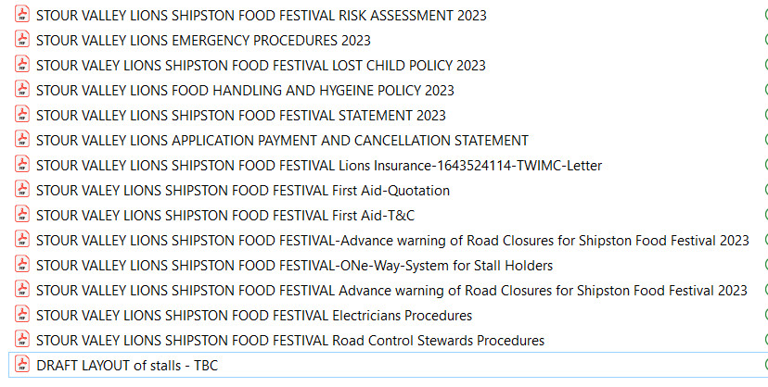
*Policies to be checked

